**MELROSE ELEMENTARY**

**Yearbook sales start**

**NOW until February 29th**

**– February 14th**

***ORDER ONLINE*** or complete order form & return to school. Please submit credit card, cash or checks made payable to ***Marty’s Studio* 330-345-7151**

**YEARBOOK OPTIONS**  All yearbooks are 8.5” x 11” soft cover with full color photos, Yearbooks will be delivered to the school by the end of May 2024.

**Credit Card Info** (Visa/MasterCard/Discover)

|  |  |  |  |  |  |  |  |  |  |  |  |  |  |  |  |
| --- | --- | --- | --- | --- | --- | --- | --- | --- | --- | --- | --- | --- | --- | --- | --- |
|  |  |  |  |  |  |  |  |  |  |  |  |  |  |  |  |

Exp. Date ___ /___ 3 Digit Code_________

Name on card_______________________

Phone #______________

**Choose a payment type. Please enclose exact amount.**

* Cash (exact change only)
* Check (payable to **Marty’s Studio**)
* Credit card (complete form below)

**Yearbook ORDER**

Yearbook Only (no name) $***16***

 Yearbook with name & photo ***$24***

 Yearbook with name **$*22***

**TOTAL AMOUNT ENCLOSED $____**

**Marty’s Studio 330-345-7151**

**$22**

**Yearbook** with **students** **name** on cover (1/2”tall)

**$16**

**Yearbook**

**Only**

**$24**

**Yearbook** with **Students name** and **Students photo** on cover (1.4”w x 1.75”h)

**Melrose Elementary**

Students Name_______________________________

Phone # ____ _____ Grade__ _

Homeroom Teacher _____________________

Personalization Name (*if applicable*)

|  |  |  |  |  |  |  |  |  |  |  |  |  |  |  |  |  |
| --- | --- | --- | --- | --- | --- | --- | --- | --- | --- | --- | --- | --- | --- | --- | --- | --- |
|  |  |  |  |  |  |  |  |  |  |  |  |  |  |  |  |  |

**––**

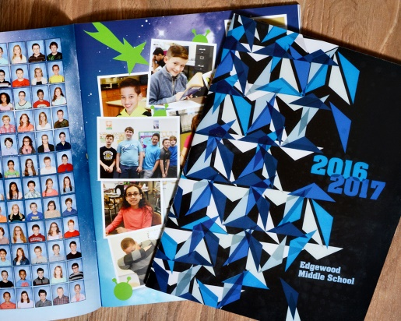 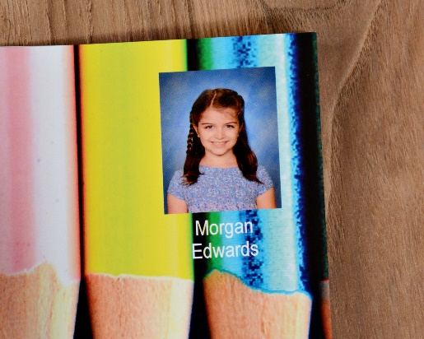 

**Order Online:**

vando.imagequix.com/g1001077708

**$16 Yearbook Only $24 Yearbook with Name & Photo $22 Yearbook with Name**